Electrical & Computer Engineering & Computer Science (ECECS)





DSCI 6007-Final Project – Showcase

Optimizing Business Operations using a Scalable Data Engineering Pipeline

Team-10: Nischal Subedi, Abhigya Bikram Malla, Ronik Karki

Contents

Project Name 1

Highlight of the project 1

Technical Report 3

Abstract 3

Review of Available Research 3

Methodology 4

Data ENGINEERING PIPELINE 6

Discussion 11

Conclusion 11

Contributions/References 11

# Project Name

**Optimizing Business Operations Using a Scalable Data Engineering Pipeline**

## Highlight of the project

Organizations face significant operational inefficiencies leading to financial losses, resource wastage, and reduced productivity. Our project focuses on building a scalable cloud-based data engineering pipeline that analyzes sales and operational data to diagnose inefficiencies, optimize processes, and enhance business performance.

The project we are introducing is "Enhancing Business Operations Through a Scalable Data Engineering Pipeline" which aims to boost business efficiency by creating a cloud-based data pipeline that analyzes sales and operational day to day data to identify inefficiencies and generate actionable insights. Numerous organizations experience resource waste, diminished productivity, and elevated operational expenses due to inefficient processes. The project we have introduced tackles these challenges by utilizing a real-world sales dataset sourced from Kaggle to pinpoint underperforming products and outlets, thus facilitating data-informed decision-making.

We start with addressing missing values, standardizing categorical variables, and creating a new metric—sales per unit weight—to better assess product performance. The data engineering pipeline was developed using AWS technologies such as S3 for storage, AWS Glue for ETL processes, AWS Athena for SQL queries, and Power BI for dynamic visual representations. This framework allows for effortless data progression from raw ingestion to actionable dashboards, offering metrics like average sales per store type, performance by item category, and sales-to-visibility ratios. These insights assist businesses in reducing underperforming SKUs, optimizing inventory and outlet operations, and making more informed resource allocation choices. While no machine learning models were implemented, the project effectively illustrates how descriptive analytics and cloud infrastructure can significantly enhance operations.

Furthermore, the future prospect may include the integration of real-time data ingestion utilizing AWS Kinesis and the introduction of predictive modeling via AWS SageMaker. In summary, this project shows the potential of scalable data pipelines and visualization platforms in helping organizations convert raw data into valuable, strategic insights.



# Technical Report

## Abstract

Organizations face significant operational inefficiencies leading to financial losses, resource wastage, and reduced productivity. Our project focuses on building a scalable cloud-based data engineering pipeline that analyzes sales and operational data to diagnose inefficiencies which inherently is going to optimize processes and enhance business performance.

**pitch video link:** [**https://drive.google.com/drive/folders/1Nlt2WsnUY39Gg13ZjDj8w736nS4UBdww**](https://drive.google.com/drive/folders/1Nlt2WsnUY39Gg13ZjDj8w736nS4UBdww)

## Review of Available Research

Recent research highlights that cloud-based data engineering-using platforms like AWS Glue and Microsoft Fabric-can dramatically cut operational costs and improve efficiency in retail and supply chain management. For example, Shop Fully achieved a 30% reduction in data pipeline costs and a sixfold improvement in processing efficiency by migrating legacy systems to AWS Glue, enabling real-time adjustments to marketing campaigns based on customer interactions and inventory data[[1]](https://aws.amazon.com/solutions/case-studies/shopfully-case-study/). By integrating real-time data streams from sales, inventory, and customer interactions, these solutions enable better forecasting and inventory control, with studies reporting up to 30% cost savings and 40% faster processing speeds. Strategic use of cloud resources, such as auto-scaling and right-sizing, further enhances cost-effectiveness and scalability. [[2]](https://papers.ssrn.com/sol3/papers.cfm?abstract_id=5068349)

However, building and maintaining efficient data pipelines presents challenges, including data quality issues and adapting to evolving business needs. Recent innovations combine AI-driven analytics with robust cloud architectures to improve demand forecasting and dynamic pricing, resulting in measurable gains in sales prediction accuracy and reduced waste. These advancements is the vital role of modern data engineering in driving business optimization [[3]](https://papers.ssrn.com/sol3/papers.cfm?abstract_id=4952077)

## Methodology

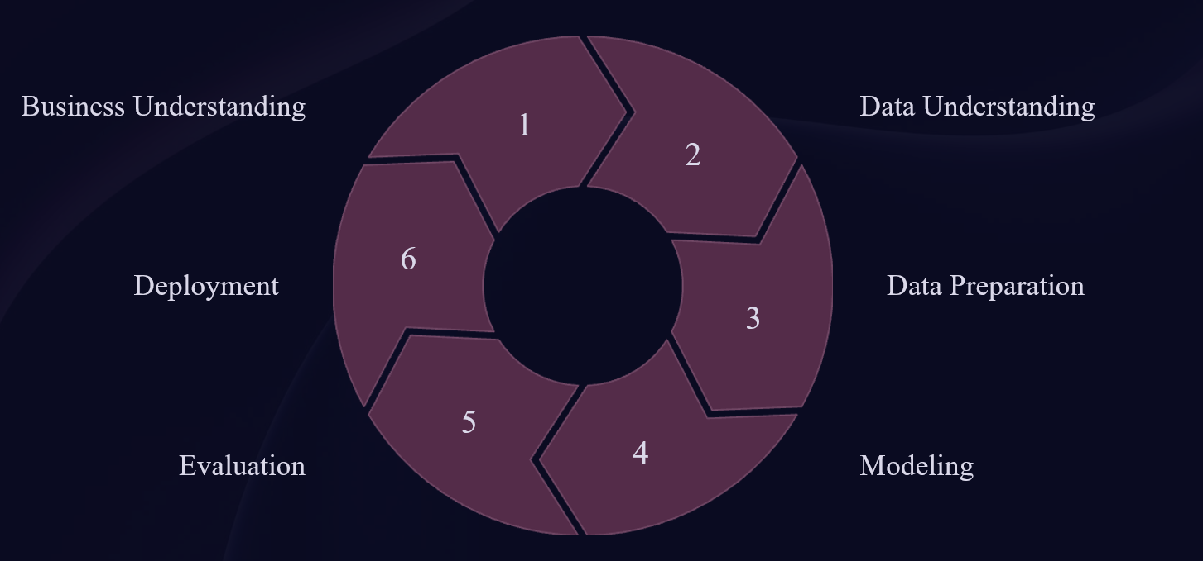

In the methodology section, we introduce the research methods and data sources used for the analysis.

* **CRISP-DM methodology:**

**1. Understanding the Business**

Our approach involved:

* The objective was to predict sales and identify crucial insights that could aid businesses in enhancing their operations. This encompasses recognizing the elements affecting sales, identifying trends, and delivering practical insights for improved decision-making.

**2. Data Understanding**

What we accomplished:

* The dataset was obtained from Kaggle – "Sales Forecasting Dataset by rohitsahoo," offering actual sales information.
* This data comprises numerous features like sales, region, state, category, and additional attributes relevant to the business.

**3. Data Preparation (Data Ingestion, Cataloging, and Processing)**

Our actions included:

* Sales data is uploaded in CSV format to the raw S3 bucket (sales-forecasting-raw/).
* A Glue Crawler scans the raw data to identify the schema and subsequently registers it in the Glue Data Catalog.
* A Glue ETL job processes the data, cleanses it, converts data types, applies transformations, and saves the cleaned data in Parquet format to the processed S3 bucket (sales-forecasting-processed/).

**4. Modeling**

What we accomplished:

* The emphasis was on utilizing aggregation and descriptive statistics to gain insights into critical metrics like overall sales, sales categorized by category, and trends over time.
* The data underwent preprocessing and aggregation to develop significant features for more in-depth analysis.

**5. Evaluation**

What we accomplished:

* Generated Key Performance Indicators (KPIs) like:
* Average sales per store type
* Sales distribution across different item categories
* Sales-to-visibility ratios

**6. Deployment (Data Querying, Visualization, and Automation)**

Data Querying: Established an Athena table for querying the finalized data.

Data Visualization: Developed an interactive Power BI dashboard to showcase total sales, regional sales, and time-series trends.

Data Pipeline Automation: Implemented an event-driven architecture to automate the data pipeline, initiating Lambda, Glue Crawler, ETL jobs, and Athena updates upon the upload of new data.

## Data ENGINEERING PIPELINE

In this section, we present the results of our end-to-end sales analytics pipeline by walking through each phase of the data engineering process that we designed, implemented, and automated. We aligned our implementation with the CRISP-DM methodology to ensure a structured and iterative approach to solving the business problem  
  
**1) Data Ingestion**

We started by setting up an Amazon S3 bucket (sales-forecasting-raw) to act as the entry point for incoming raw sales data in CSV format. Sales files can be uploaded either manually or through automated methods.

To streamline this process, we developed an AWS Lambda function that activates whenever a new CSV file is added to the raw bucket. This Lambda function initiates the subsequent processes, allowing for real-time ingestion without the need for manual intervention.

**2)Data Storage**

Amazon S3 was utilized to keep both the raw and processed data:

* The raw data is kept in the sales-forecasting-raw bucket.
* Processed data is stored in the sales-forecasting-processed bucket in Parquet format, which was selected for its efficient columnar storage and superior querying performance.

**3)Data Preprocessing**

For data processing, AWS Glue was employed for schema identification and transformation purposes:

* A Glue Crawler inspects the raw S3 files and records their structure in the Glue Data Catalog, automatically updating the schema.

As soon as the crawler completes its task, a Glue ETL Job (using PySpark) is initiated.

This job:

* Converts the sales column to a numeric format
* Excludes null or malformed entries
* Chooses and renames pertinent fields
* Normalizes the sales_category column into "High," "Medium," and "Low"
* Saves the cleaned data in Parquet format to the designated processed S3 bucket.
* The entire ETL process is seamlessly integrated with the ingestion workflow for complete automation.

**4)Data Consumption**

Following the transformation, the data is prepared for querying:

* A table called final_output_safe has been established in the sales_forecasting Glue database using Amazon Athena.
* We utilized Amazon Athena to execute SQL queries directly on the modified S3 data, removing the requirement for specific compute resources.
* Additionally, this table serves as the data source for Power BI.

**5)Model Deployment / Pipeline Automation**

While this project did not involve the deployment of predictive models, we established a completely automated, serverless data engineering pipeline.

Pipeline Flow:

* A new CSV is uploaded to S3.
* This action activates AWS Lambda.
* Lambda then initiates the Glue Crawler, which refreshes the schema.
* Following that, Lambda starts the Glue ETL Job, which processes and saves the cleaned data.
* This setup guarantees smooth, event-driven execution without any manual involvement.

**6)Data Visualization**

After setting up our end-to-end pipeline, we were able to build a fully interactive dashboard in PowerBI. The dashboard that is created shows cleaned, categorized and transformed data from Amazon S3 with the help GLUE ETL job and Athena Integration. To categorize the data we decided on a threshold during the ETL process:

* Sales exceeding 1000 were classified as High
* Sales ranging from 100 to 1000 were designated as Medium
* Sales of 100 or less were categorized as Low

This classification allowed us to analyze performance by state and region more clearly.

The total results indicate that total sales reached 2.26 million, with the average sales per order approximately at 1.34K—suggesting a strong presence of high-value transactions overall. Again, to demonstrate the interactivity of the dashboard, we also created a filter version focused on the East Region. Moreover dashboards indicates that total sales rose from $600.19K in 2017 to $722.05K in 2018, accompanied by a notable increase in average sales per order from $299.07 to $1,340, largely propelled by the growth in high-value transactions, particularly in the West and East regions, with California and New York continuing to be the leading states in both years.

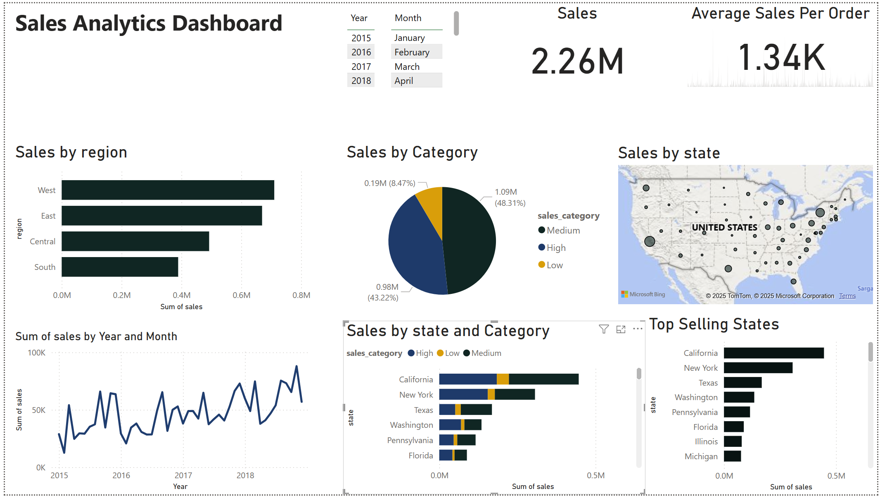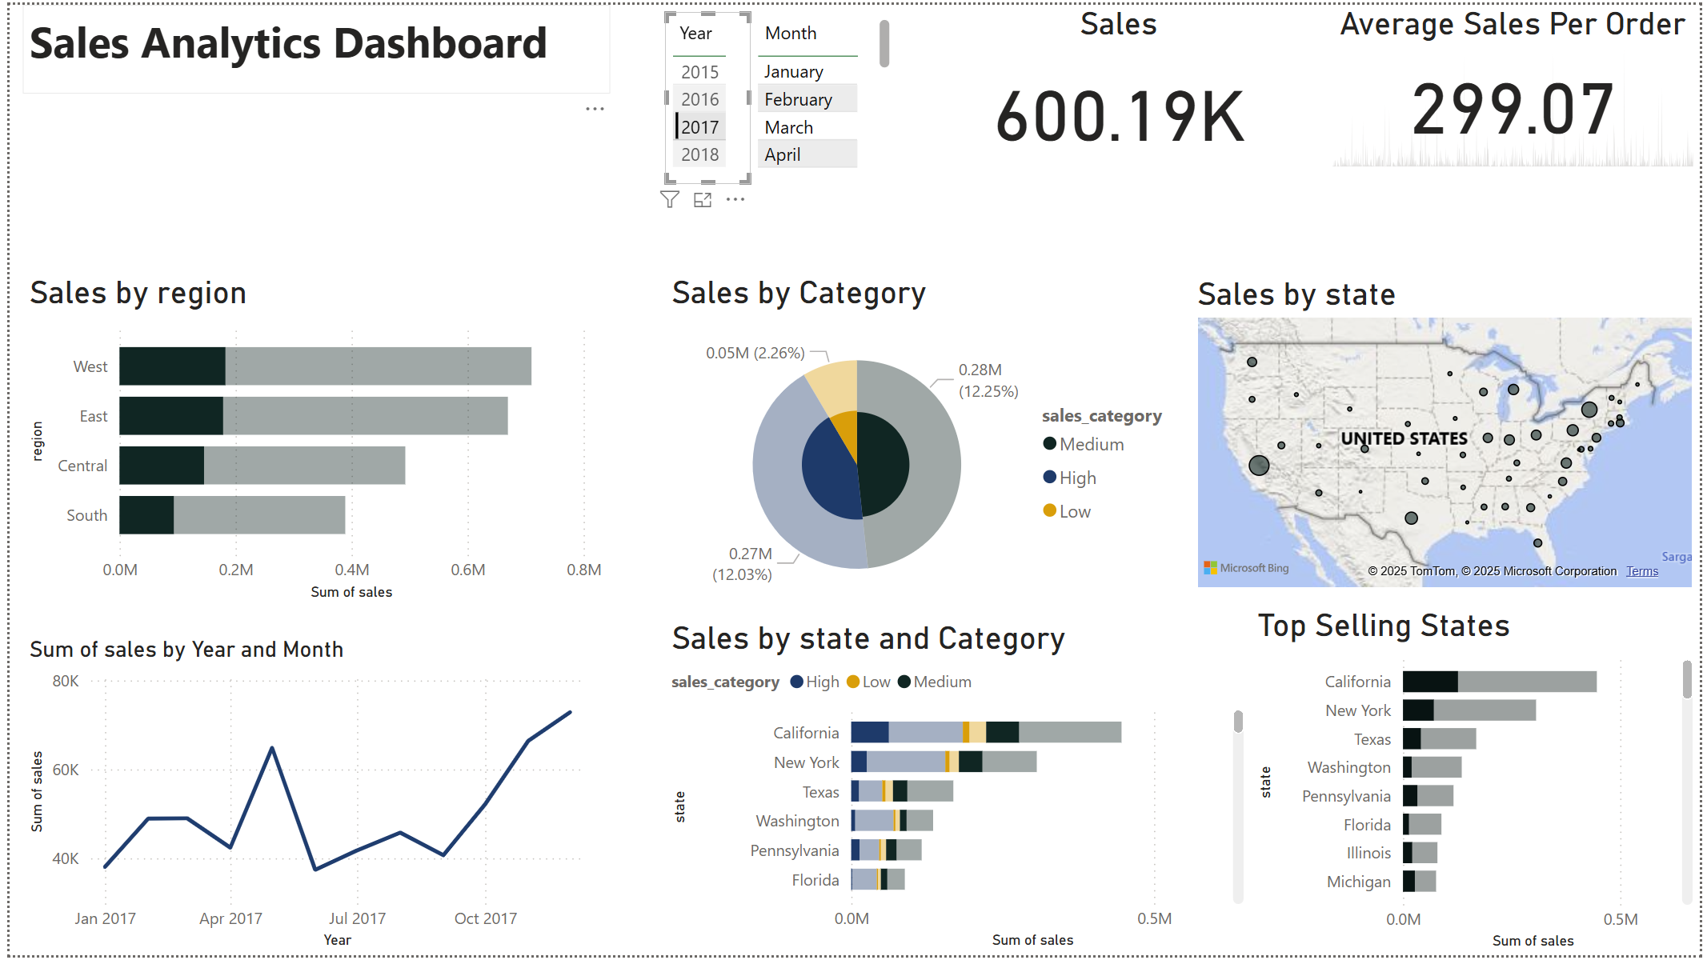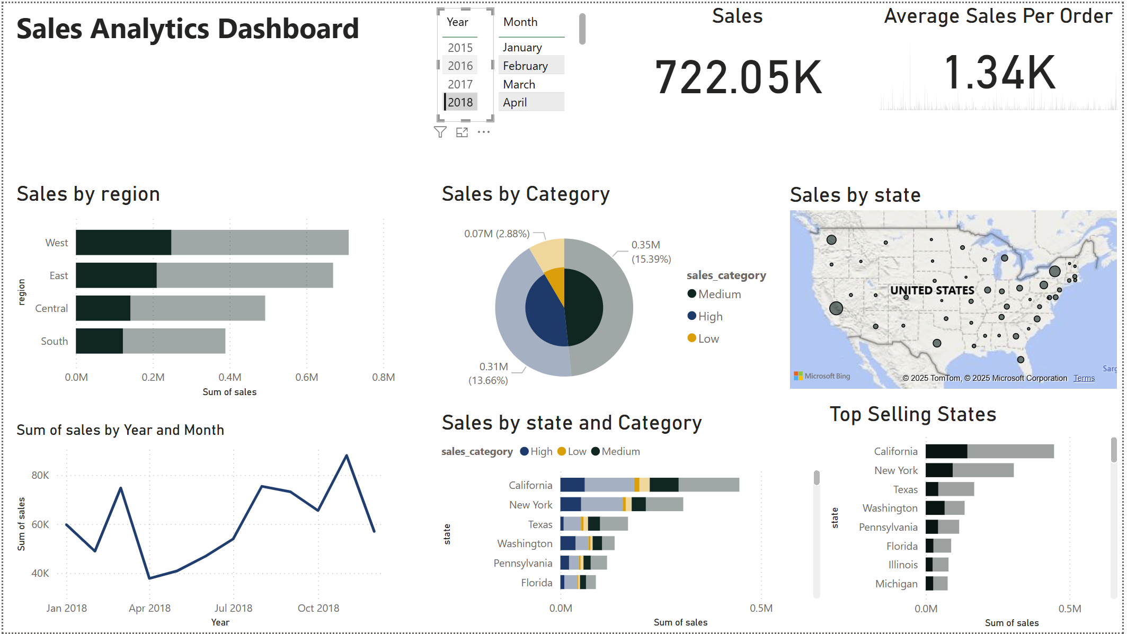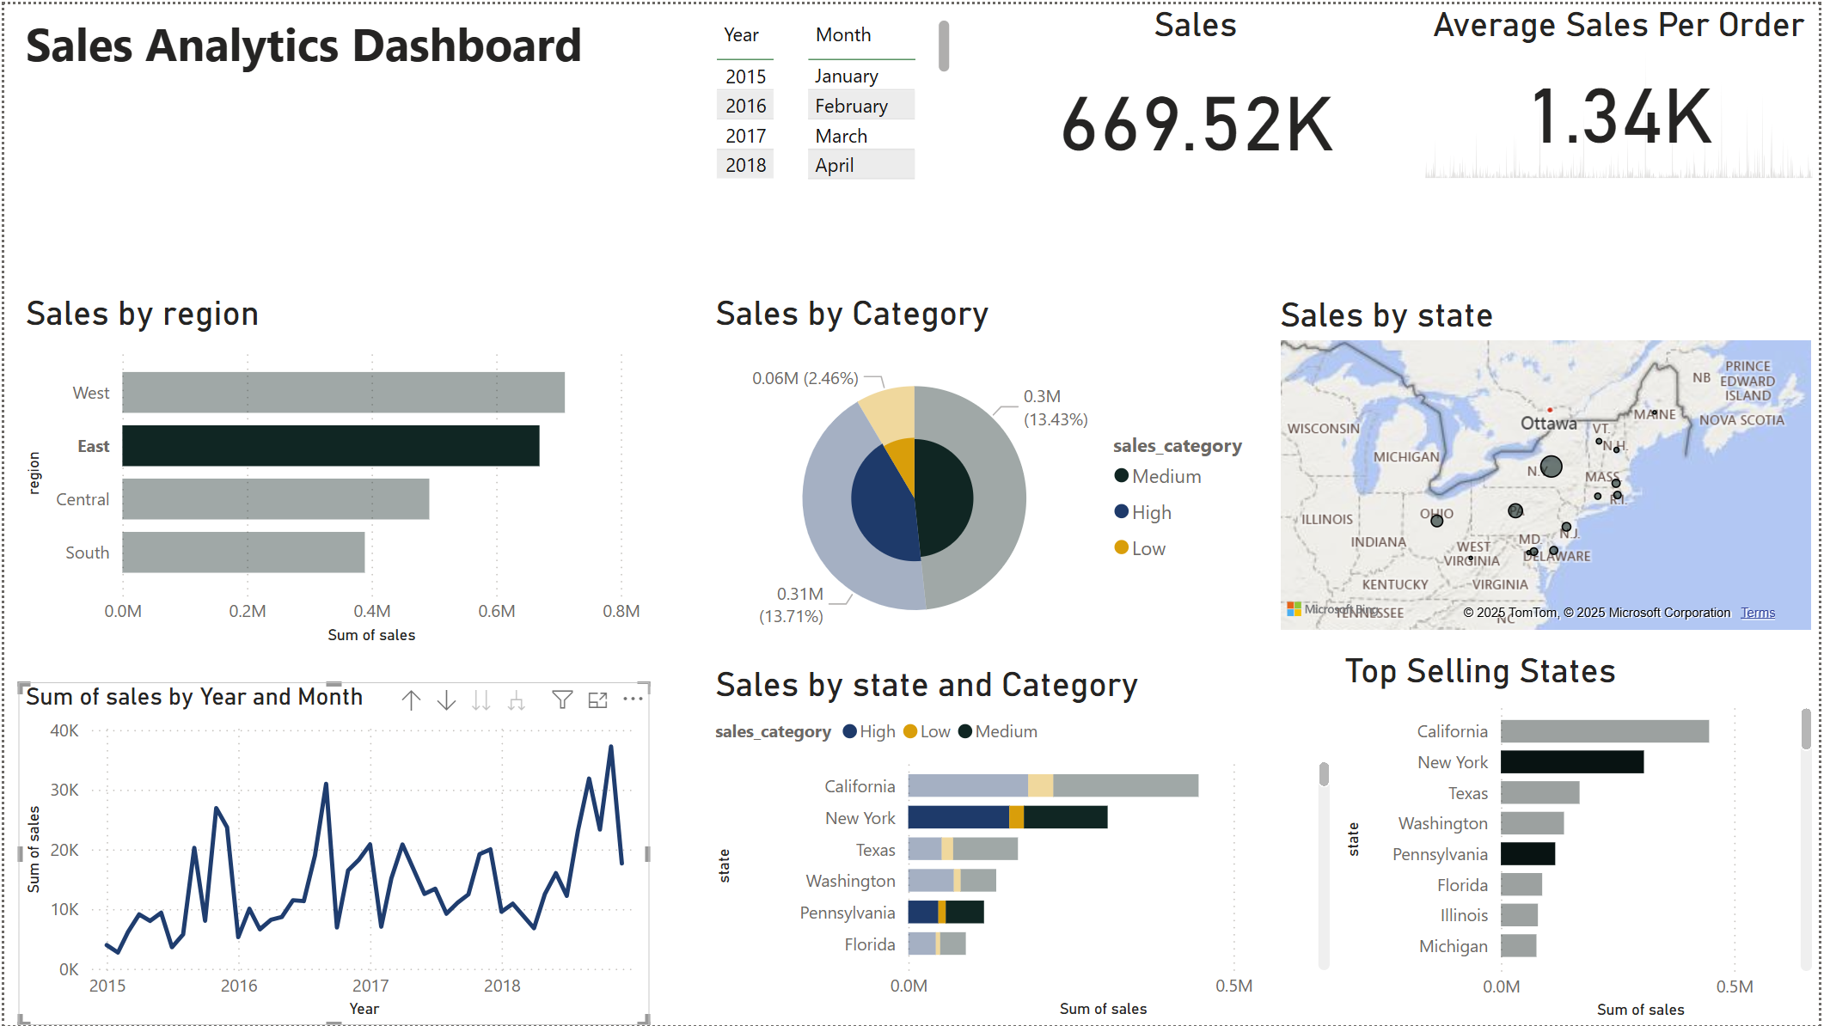

Behind the scenes, we achieved all of this through the automated pipeline we developed. It all begins with uploading a CSV file to S3, which then triggers a Lambda function, runs a Glue Crawler to organize the data, processes it using a Glue ETL job (including our sales categorization logic), and saves the cleaned data in Parquet format. Afterward, Athena makes the data quarriable, and Power BI visualizes it. The entire process operates from start to finish without any manual intervention—simply upload the data and prepare the dashboard for exploration.

## Discussion

The implementation of our scalable data engineering pipeline highlights the transformative impact that cloud-based analytics can have on business operations, as detailed in our project. By leveraging AWS technologies such as S3, Glue, and Athena, alongside Power BI for visualization, we were able to efficiently process and analyze large volumes of sales and operational data that we accessed through Kaggle. This approach shows how it optimizes business performance.

Our results, such as identifying a strong presence of high-value transactions and regional performance analysis, demonstrate the value of descriptive analytics in operational decision-making. Although we did not deploy any machine learning models, the project clearly demonstrates that even simple aggregation and categorization, when backed by a strong cloud infrastructure, can lead to substantial business advantages. This experience also brought to light some challenges, including the necessity to carefully establish data categorization thresholds and the possible benefits of incorporating real-time data ingestion and predictive analytics in the future. Overall, this project illustrates how modern data engineering can empower organizations to move from raw data to strategic insights, setting the stage for more advanced analytics as business needs evolve.

## Conclusion

We have successfully demonstrated how a well-architected data engineering pipeline can transform raw business data into intelligence that has the capacity to address operational inefficiencies. By implementing a comprehensive cloud-based solution using AWS technologies (S3, Glue, Athena) and Power BI, we have created a scalable framework that enables organizations to make data-driven decisions that optimize their business operations. For future development, we propose real-time ingestion with AWS Kinesis and predictive modeling with Sage Maker.

## Contributions/References

Team Members:

* Nischal Subedi -- Team Leader
* Abhigya Malla -- Data Engineer
* Ronik Karki -- Visualization & Storytelling Lead